**Explore Weather trends**

# 1. Questions answered

1. What tools did you use for each step? (Python, SQL, Excel, etc)

Used SQL to extract the data from the database

* select * from global_data
* select * from city_data
* select * from city_list

Used Python for analysis and visualization

* city_data = pd.read_csv W('City_data.csv')
* global_data = pd.read_csv ('Global_data.csv')
* pune_data = city_data [city_data ['city'] == 'Pune']

2. How did you calculate the moving average?

Used Python for calculating the Moving average

* pune_data['Rolling'] = pune_data.rolling(10).mean()['avg_temp']
* global_data['Rolling'] = global_data.rolling(10).mean()['avg_temp']

3. What were your key considerations while deciding how to visualize the trends?

* All the markings in the visualization must be clear to the reader.
* Some data was missing from the tables, so we need to fill in this data as missing data creates problem while visualizing
* Changing the moving average window as to see the how the number affects the graphs.

**2. VISUALIZATION**

1. Average temperature of the world v/s Average temperature of Pune (My city).

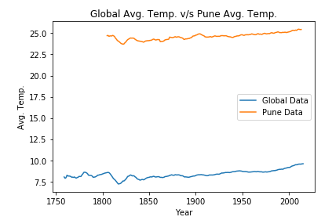

2. 7 Years Moving Average: Average temperature of the world v/s Average temperature of Pune (My city).

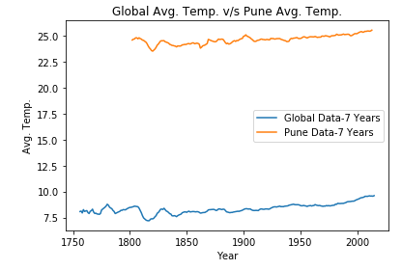

3. 10 Years Moving Average: Average temperature of the world v/s Average temperature of Pune (My city).

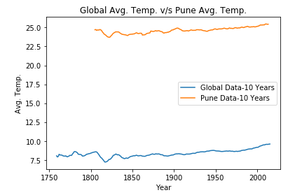

**3. Observations**

1. Pune has a very high average temperature as compared to the world.
2. During the period between 1800s and 1830s there was a sudden drop in the global as well as Pune’s temperature.
3. Both the temperatures seem to be getting hotter and hotter day by day.
4. The increase in global average temperature is slightly higher than the increase in temperature of Pune.

**4. ANALYSIS**

| CRITERIA | MEETS SPECIFICATIONS | Self evaluation |
| --- | --- | --- |
| Student is able to extract data from a database using SQL. | * The SQL query used to extract the data is included. * The query runs without error and pulls the intended data. | Completed |
| Student is able to manipulate data in a spreadsheet or similar tool. | Moving averages are calculated to be used in the line chart. | Completed |
| Student is able to create a clear data visualization. | * A line chart is included in the submission. * The chart and its axes have titles, and there's a clear legend (if applicable). | Completed |
| Student is able to interpret a data visualization. | * The student includes four observations about their provided data visualization. * The four observations are accurate. | Completed |